Created by Lionel Weber, the 27 November 2009
Modified by Lionel Weber, the 15 May 2013

Wigii Emailing activity concepts

The Emailing activity can be enabled per Emails field. The service is enable if there is at least one Emails field. You can define if you want to enable or disable the service for each Emails field with the field attribute enableForEmailing.
<contacts>
<fields>
...
<email type="Emails" enableForEmailing="1" isMultiple="1" />

The config of the Emailing activity made in the global config as it is a standard activity. However it could be redefined in a specific configuration. In this case ensure to create a surcharge of EmailingFormExecutor to treat correctly your specific configurations.

<Emailing>
<fields>
<from_email type="Emails" require="1" />
<to_email type="Emails" require="1" isInLine="1" isMultiple="1" />
<attachedFile0 type="Files" require="0" noLabel="1" >
<label_l01>Attached file 1</label_l01>
<label_l02>Fichier attaché 1</label_l02>
</attachedFile0>
...
<attachedFile14 type="Files" require="0" noLabel="1" >
<label_l01>Attached file 15</label_l01>
<label_l02>Fichier attaché 15</label_l02>
</attachedFile14>
<object type="Strings" require="0" />
<message type="Blobs" require="1" isInline="0"
htmlArea="1" activateHtmlArea="1"
fullToolbarHtmlArea="1"
template=""
height="300"
/>
</fields>
</Emailing>

To prevent using this activity to send emails to other emails of the system you can add readonly="1" to the to_email field.

The message field is configured to give the full CKEditor toolbar to allow people writing nice looking emails. If you want to prefill the email message with a template you can define an existing CKEditor template in the template attribute (this template needs to be defined in your www/CKTemplate.js file in your Client folder). If the width of the Emailing dialog doesn’t fits you, you can define in your module config parameters the following attributs: sendEmailTotalWidth="650" and sendEmailLabelWidth="200"

The service is coded to use those specific fields. The number of attachedFile can be increased using the same syntax. By default they will appears one after the other.

The message is configured to be a rich html editor, and that this editor is enabled by default.

The email is build following this logic:
- from: from_email value
- bcc: to_email value
- object: object
- attachement: each attachedFile which is filled
- message: message

Note: if you want to define the template used to construct these emails, like for i.e. add a header or a signature to all your emails, lookup the “Wigii Customize Email templates.doc”

Email merge concepts

The emailing feature is very powerful to send emails. However we often need to send more personalized emails. In order to do that, the Wigii system implements a field merge feature. This feature is enabled by adding to the Emails fields attributes such:
label1, label2, label3, labelSep, other1, other2, other3. Each of those attribute can refer to an existing field. If those merge fields appears in the Email body such in the format: $label$ or $other1$ or $other2$ or $other3$ there are replaced by the value of the field there refer to.
Note: there is not $label1$. This is because the merge field $label$ is the result of the field referred in label1 + label2 + label3 separated with the character defined in labelSep.

I.E:
In the configuration the email1 field is defined such as:
<email1 label1="first_name" label2="last_name" other1="gender" other2="positionTitle" type="Emails" enableForEmailing="1" />
(if labelSep is not defined a space is automatically used)

The emailing window provides the following merge fields:
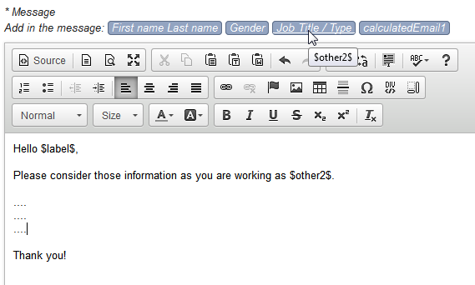

This will send one email to each selected contacts with replacing the merge fields with the personnal values.

This whole process is done in: EmailingFormExecutor->processRecipients() (when sending emails), AddSubscriptionFormExecutor->actOnCheckedRecord() (when sending the confirmation email), ExternalEditAccessFormExecutor->actOnCheckedRecord() (this process lookup if there is a confirmation email setup in the subscription parameters, in this case a confirmation email is sent with the merging system).

Those methods actually only prepares the mergeData array in the following format:
$mergeData = array(
"john.dupont@wigii.ch"=>array(
'$label$'=>'John Dupont',
'$other1$'=>'Male',
'$other2$'=>'Finance officer',
'$email$'=>'john.dupont@wigii.ch',
'$confirmation$'=>'....',
'$access$'=>'....'),
...
);

This array is used in EmailServiceWebImpl->send(). This method creates one email per mergeData value. The WigiiEmailWebImpl->mergeData() method replace in the body and the subject any merge fields with the correct data.

Send a test email concept
As Emailing can be used to broad communication you might want to ensure how your email looks like before sending it to everybody. This can be performed by clicking on the “Send a test email” button. This button will send the current email you have written to the “From” email. The email subject will have the text “TEST: ” added in front of the subject.
Note: if the email contains some merge fields, the test email will be sent with the first merge data. Like this you can check one “real” result.

The “Send a test email” simply change the hidden field action to : sendTestEmail. Then the EmailingFormExecutor detects if the form is in the state: sendTestEmail. In this case the form is not closed, and a test email with the result of the first merging data is sent to the “From” address. This check is done in: EmailingFormExecutor->doRenderForm(), EmailingFormExecutor->doSpecificChecks() (to not close the dialog box), EmailingFormExecutor->actOncheckedRecord() (to send the test email), EmailingFormExecutor->addAttachements() (copy temporally the attachments in order to keep the original ones for the real email), EmailingFormExecutor->processRecipients() (add the “From” as the recipients).

